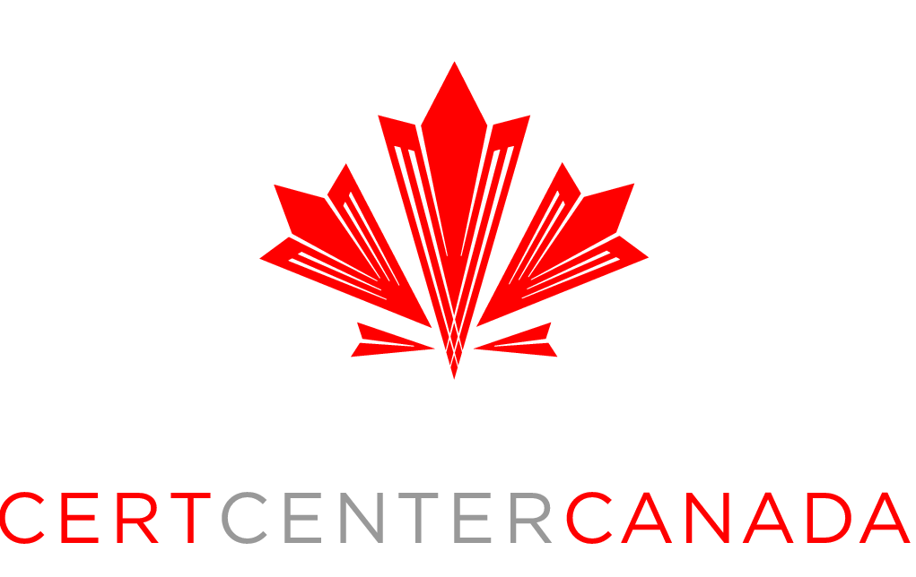
Press Contact:
Alistair Chapman
Director of Marketing
Certification Center Canada
Alistair.chapman@certcentercanada.com

PRESS RELEASE

For immediate release

CERTIFICATION CENTER CANADA TO OPEN A NEW FACILITY IN COOPERATION WITH CENTRE TECHNOLOGIQUE EN AÉROSPATIALE

Montréal, May 24 May 2021. Certification Center Canada (3C) and Centre technologique en aérospatiale (CTA) today announced that 3C will be opening a new facility inside of CTA to aid in the advancement of future aircraft technologies.

3C’s Centre for Future Aerospace Technologies Evaluation, Flight Test and Certification (CFATE) will provide a place and focal point for the development of the new technologies that the aerospace sector needs and a location, including infrastructure and equipment, where companies can flight test, evaluate and certify those technologies.

CFATE will allow 3C to expand its capabilities and increase capacity for training and mentoring future aerospace professionals through a close collaboration with both CTA and Cégep Édouard-Montpetit’s École nationale d'aérotechnique (ÉNA).

CFATE has been made possible at this time, in part, by funding assistance provided by the Québec Government as part of the recently announced “PROJETS COLLABORATIFS DE L’AÉRONEF DE DEMAIN“ program designed to accelerate technology development, digital transformation and knowledge for the advancement of future aircraft, including hybrid electric and the implementation of associated services.

Quote 3C
“3C is particularly grateful to the Québec Ministry of Economy and Innovation, whose support under the aforementioned project was instrumental in allowing us to accelerate our commitment to expand our services as we transition out of the COVID-19 pandemic,” said Phil Cole, Vice-President Business Development at 3C. “Being able to solidify and expand the relationship that we have forged with CTA over the past few years by collocating with them and working together on new projects, technologies and capabilities has long been a goal for us. We are delighted to have such a partner that shares common goals for the aerospace industry in Québec and look forward to helping to transform the industry together for the benefit of the entire aerospace sector in Québec.”

Quote CTA
“The entire CTA team is extremely confident that this partnership with 3C and the creation of CFATE will facilitate the development of future, more eco-friendly, aircraft,” says Francis Archambault, CTA’s Director General. “This is the first step in the creation of a flight test hub, which will fill a strategic need in Québec and Canada. Recognized in the industry, 3C’s well-established expertise in flight testing and R&D will be a valuable asset for the new Centre, which will also benefit from our equipment and R&D expertise. CTA and 3C are becoming key players in the majority of recovery projects that will require the development of applied aerospace research, flight testing or training for new technologies. The founding of the CFATE is in keeping with the vision of the Longueuil aerospace zone shared by CTA and Cégep Édouard-Montpetit.”

About Certification Center Canada - Certification Center Canada (3C) is an independent flight test and certification center providing a wide range of services to the aerospace community in Canada and around the world. Founded in 2016 and headquartered on the outskirts of Montreal, Cert Center Canada (Transport Canada approved independent flight test and certification DAO) provides a Canada-wide centralized resource with proven management, tools, and methods to undertake civil and military aerospace projects requiring flight test and certification.. For more information, visit: www.certcentercanada.com

About CENTRE TECHNOLOGIQUE EN AÉROSPATIALE (CTA) - CTA is a college technology transfer centre affiliated with Cégep Édouard-Montpetit and located on the campus of École nationale d’aérotechnique. Specializing in aerospace technology applications, CTA supports the efforts of companies in the sector to increase their knowledge, productivity, competitiveness, and the quality of their products and services. With more than 70 experts in metal and robotic manufacturing, composite materials, non-destructive inspection, avionics and flight operations, CTA is recognized for its complementarity with the various players in research and technology transfer in the aeronautical sector. To learn more about Centre technologique en aérospatiale, its sectors of activity, its facilities and its experienced specialists, visit www.aerospatiale.org.

